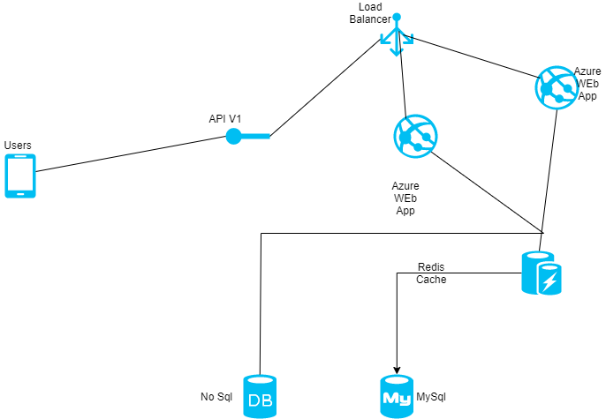

1. User access the web app in browser and signs in
2. Makes a request to an API endpoint behind a load balancer
3. The web application queries the DB and stores frequent queries as cache using Redis cache hence reducing the workload of the application.
4. The Dotnet app is loaded into the Azure Web App Service which is a Serverless PaaS.
5. The NoSql is used to store datasets which the application uses.